 | SCHEDULE OF FIXED ASSETS AT 31/03/2026
 | Description | Date Acquired | Cost Value |  | Where sited |  | Life expectancy |  | Replacement cost
1 | Bus shelter | Not known | £6,425.00 |  | Finstall Road at junction with Penmanor |  | 30 years |  | £6,000
2 | Bus shelter | Not known |  |  | Alcester Road opposite junction with Finstall Rd |  | 20 years |  | £4,000
3 | 4no. H/ways flower boxes | 1995 | £900.00 |  | Various roadside sites |  | 25 years |  | £350 each
4 | Slide | 1.1.1998 | £2,609.00 |  | Penmanor playing field |  | 40 years |  | £4,500 min
5 | Double Bay Swings | Not known | £923.00 |  | Penmanor playing field |  | 40 years |  | £5,300 min
6 | Metal Igloo Climbing Frame | 4.2.2003 | £2,411.00 |  | Penmanor playing field |  | 40 years |  | £4,500 min
7 | Spring seat/bouncer | 10/2023 | £1.00 |  | Penmanor playing field |  | 15 years |  | £1,500 min
8 | Recycled wood Seats x 3 | Not known | £2,250.00 |  | Penmanor playing field |  | 40 years |  | £800 each
9 | Goal Posts x 1 | 1.10.02 | £1,840.00 |  | Penmanor playing field |  | 10 years |  | £1,500
10 | Metal Bench | Not known | £117.00 |  | Penmanor playing field |  | 25 years |  | £250
11 | Notice board | Not known | ? |  | Penmanor p/field, entrance |  | 25 years |  | £500
12 | Chairman's Chain of Office | 1.9.2005 | £850.00 |  | Chairman's home |  | 80 years |  | £1,000
13 | Notice Board At Village Hall | 16/10/25 | £500.00 |  | Finstall Village Hall |  | 20 years |  | £500
14 | Notice board, Penmanor bus shelter | ? | ? |  |  |  | 20 years |  | £800
15 | Millennium seats x 1 | 2.11.1999 | £315.00 |  | Entrance to Penmanor |  | 40 years |  | £500 each
16 | Speed Indicator Device | 09/12/19 | £3,150.00 |  | Alcester Road |  | 10 years |  | £3,500
17 | Laptop, ASUS | 07/06/23 | £207.50 |  | Clerk's home |  | 5 years |  | £350
18 | Litter / dog waste bins includes Glasdon 35L X4 | 01/10/2024 | £1200.00 |  | Playing field |  | 10 years |  | £300 each
19 | Grit bins x2 | Various | £500.00 |  | By pub and by canal |  | 20 years |  | £250 each
20 | Notice Board At Village Hall for PC | 16/10/25 | £500.00 |  | Finstall Village Hall for PC |  | 20 years |  | £500
 |  | Total assets | £24698.50
Assets leased from Bromsgrove DC
 | Penmanor Playing Field | 15-year lease to 2039.
 | Penmanor allotments

- Bus shelter, Penmanor (Finstall Road junction)

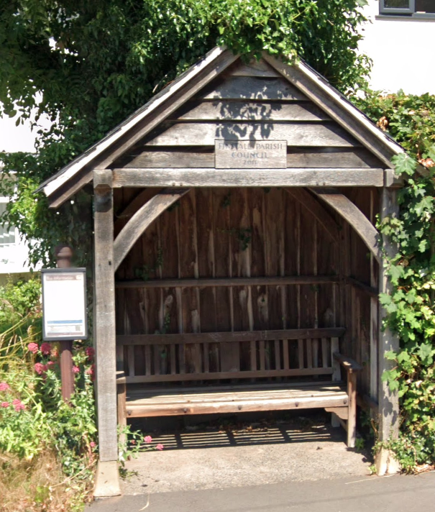
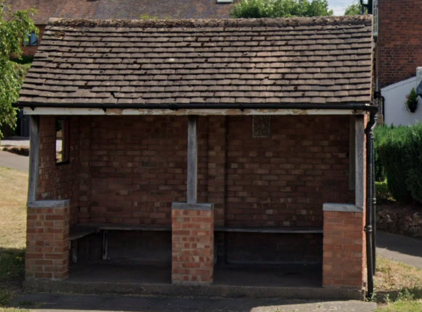

- Bus shelter, Alcester Road (Finstall Road junction).

- Highways flower boxes:

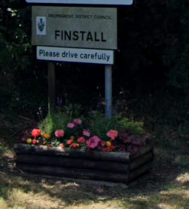
  - Alcester Road, eastern entrance to village.

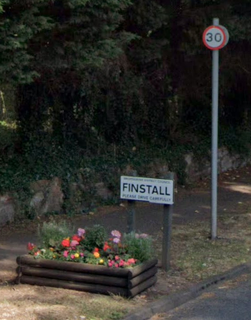
  - Finstall Road, south-west entrance to village, by St Godwalds church yard.

  - Alcester Road, north-west entrance to village, by Pikes Pool Lane.
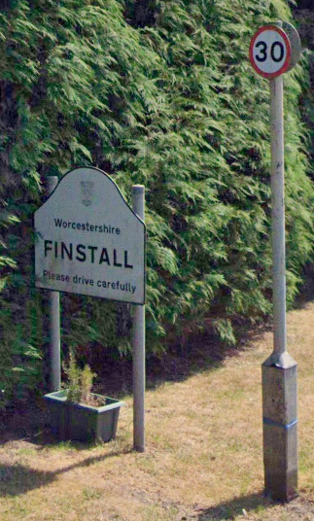

Item 3.4 Entrance to Penmanor, off Finstall Road.
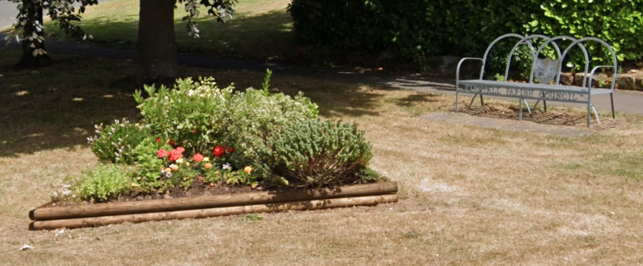

Items 4, 5 and 6: Slide, 2-bay swings and igloo climber, Penmanor Playing Field: photo June 2023.
New matting installed under the swings, 10/2023 by MJW Fabrications.

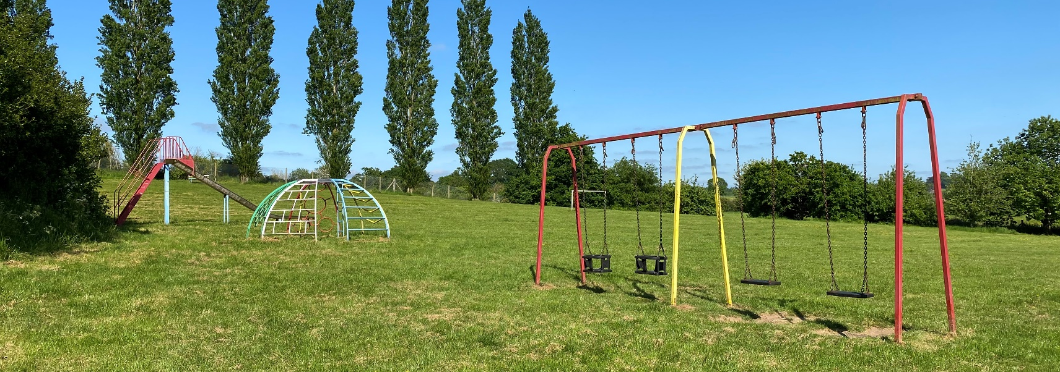

Item 7: Spring seat bouncer, installed 10/2023. Obtained free of charge from Bewdley TC. Matting and installation via MJW Fabrications.
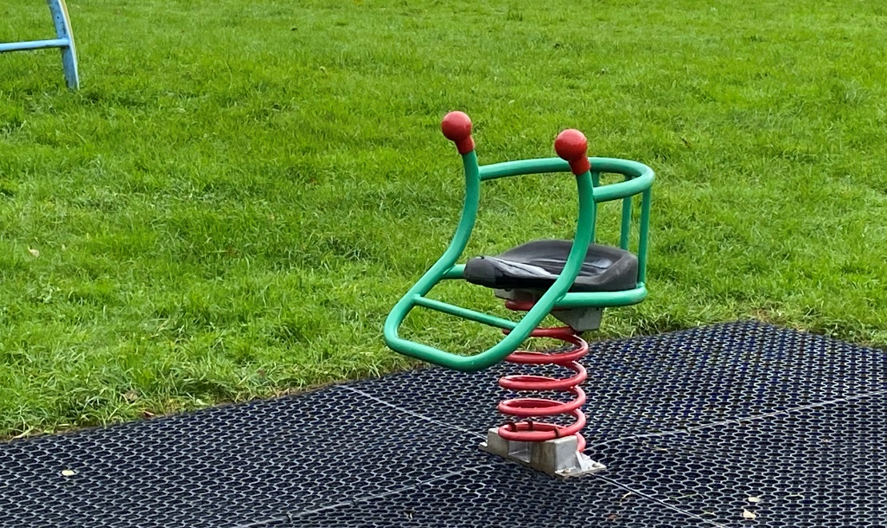

Items 8.1, 8.2 and 8.3

+

Two along north-west hedge

South-west hedge.
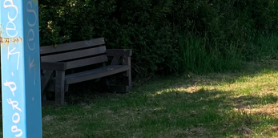
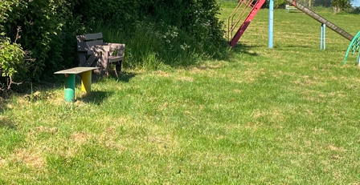

Close up of one of the 2 along north-west hedge.

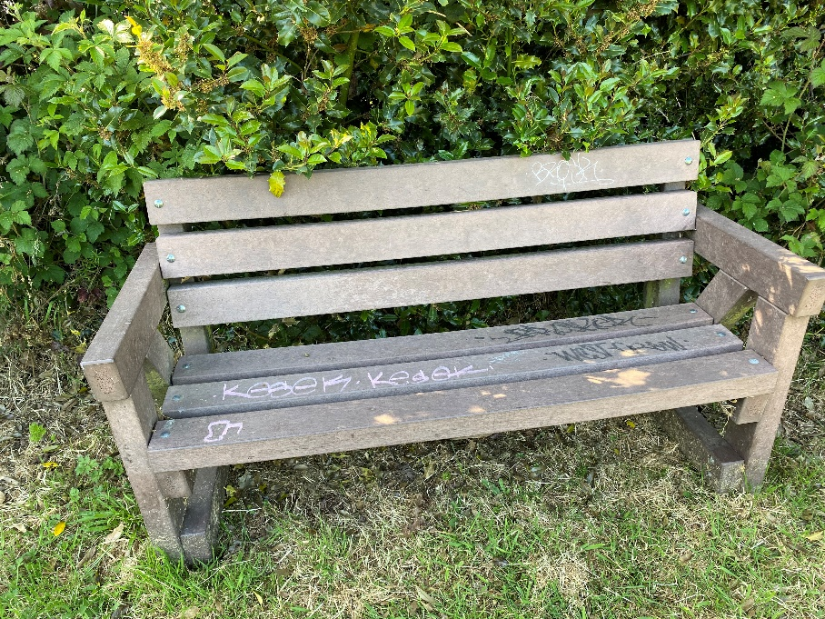
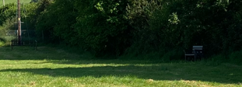

Item 9: goal post (just the one)


Item 10: metal bench seat

Item 15: notice board at Finstall Village Hall.

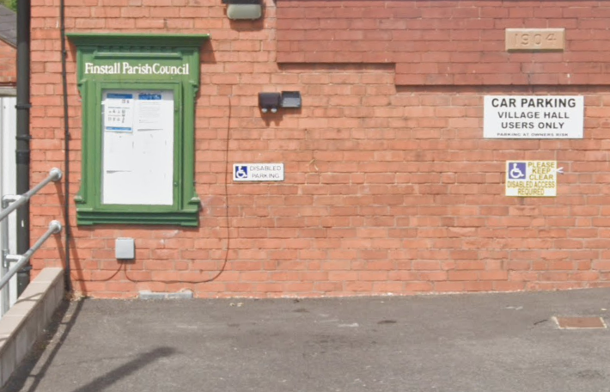

Item 16: notice board at Penmanor bus shelter.
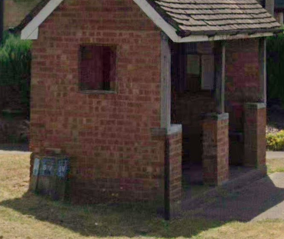

Items 17.1 and 17.2 Benches at entrance to Penmanor.



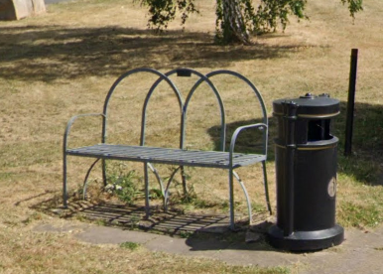

Item 18: Speed Indicator Device.
Can be re-sited as required.

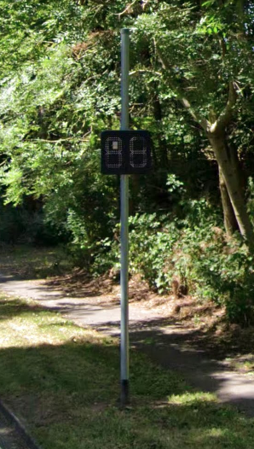

Item 20
Monarch’s Way noticeboard on footpath past rugby club, Finstall Road.
Item 21
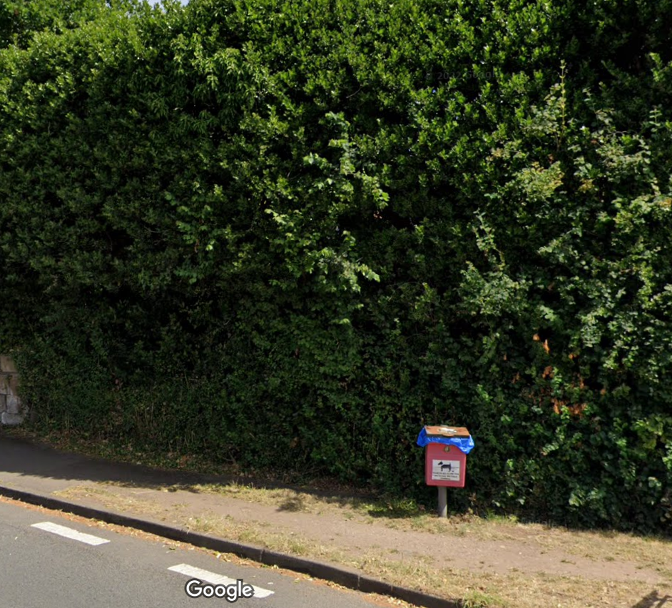
Dog waste bins; footpath past rugby club, Finstall Road Finstall Road by junction with Walnut Lane
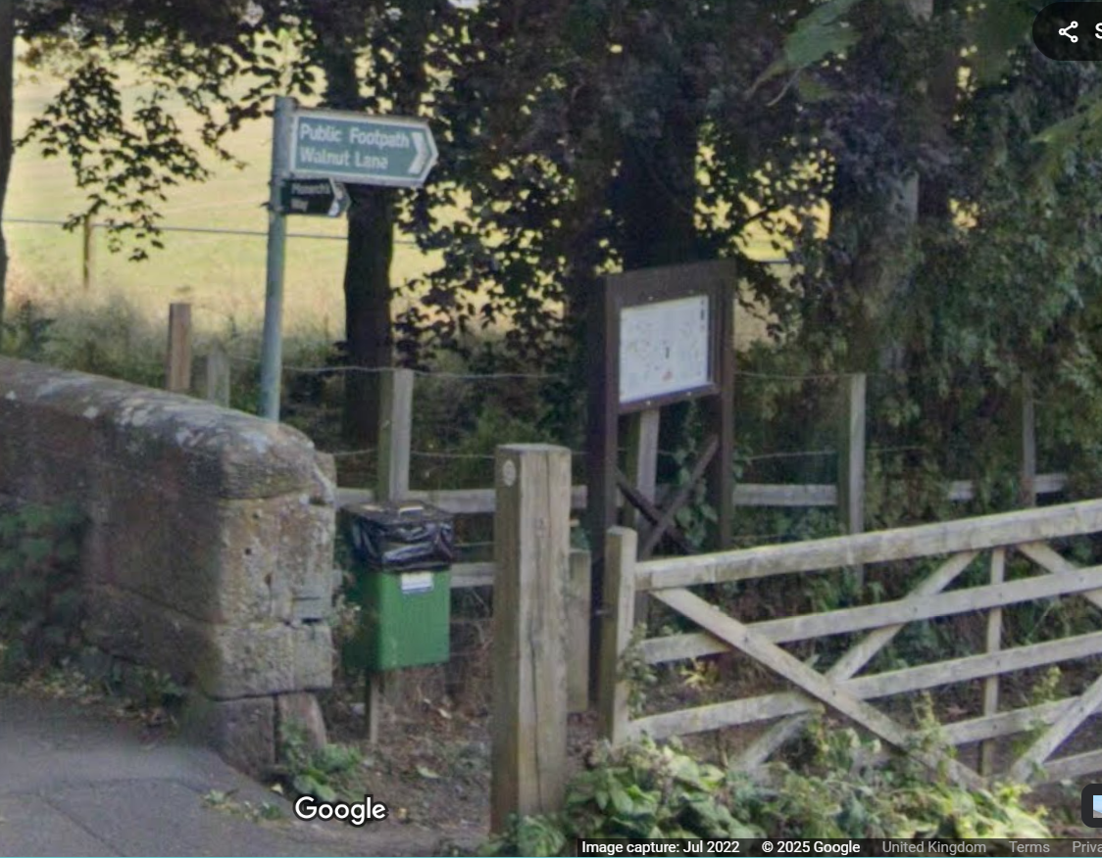

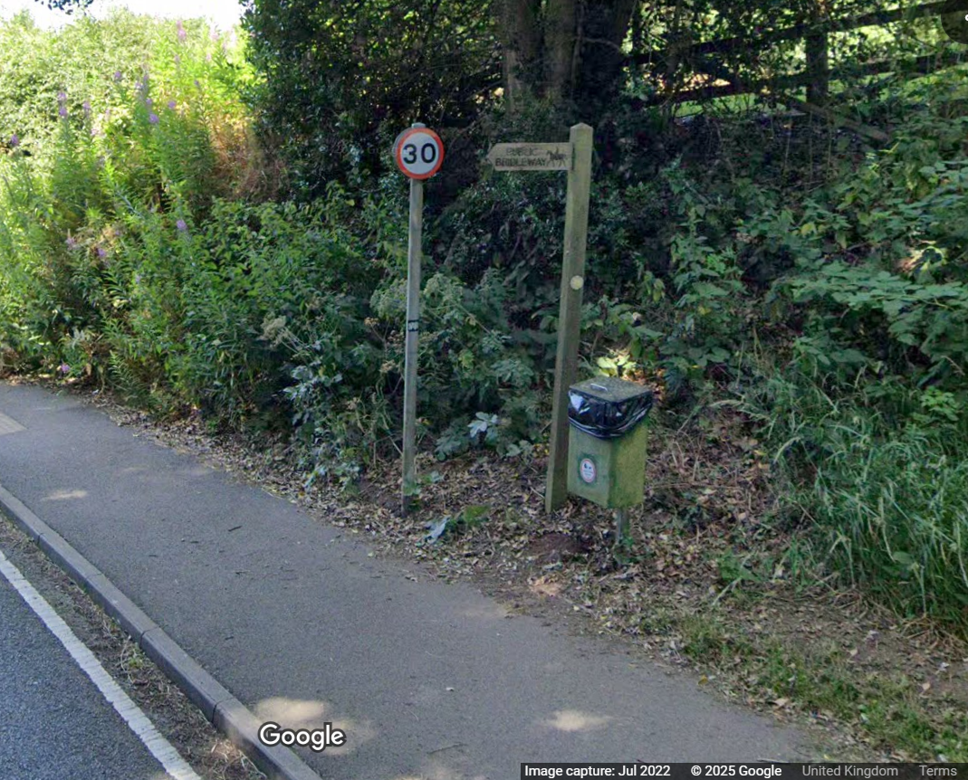
Item 21
Dog waste bins
Alcester Road (approach to Finstall from Tutnall/Redditch).

Picture awaited of bins on Penmanor Rec.
Item 22: Parish Grit bins
Upper Gambolds Lane Alcester Road / Finstall Road junction.
On roadside near to canal car park. On roadside outside The Cross Inn ph

